**Plans for today:**

I plan on splitting up the class by professor this time. Since students in the Saturday section are on chapter 5, and those who have class during the week are on chapter 4, both groups will be working on two problems from their respective homeworks each. I’ve made sure to pick questions from the homeworks that nobody has done yet.

Originally I had intended to create a worksheet for each section based on these problems, but I didn’t have enough time to do that over the weekend. Instead, I had the students work on the problems in class in groups together as I went around to check how they were doing.

**What happened**:

In the beginning, I showed each of the problems on the projector for both sections. Not everyone brought their laptop to class, so I resorted to keeping one of the problems up on the projector. I offered to show more than one problem up on the screen by splitting the screen, but everyone seemed to be working just fine.

I also told students to take a look at the new projects assigned to them this week, just in case they were already done with the homework already. A couple of students decided to work on the project from their section.

At times during class today, I found myself spending too much time with one student, just because the problems are lengthy and require that extra time to explain the full picture. To compensate, I tried told students who were working on the same problem to work in groups together, so that I wouldn’t have to spend so much time on each student. I resorted to the board to explain a problem that many students were working on. Other groups from both sections working on separate problems, also payed attention to what I was explaining on the board, just because of the difficulty of the problem.

On the board, I intentionally showed the long way of solving the problem, to get them to work on concepts that they had been struggling with the week before. After conceptually going through the problem, I encouraged students to work on the problem on their own at home, and that I would be sending them a shell for the problem to help them get started.

After the end of class, I excused students who needed to leave; however, I asked students to stay for another 10 minutes to go over a much simpler way of solving the problem. After going over it on the board, I encouraged students to try to solve the problem using the new way that I showed as well. I’m writing up the email that contains both shells for both methods.

At the very end of class, I made sure to mention the idea of midterm progress meetups. I explained what it was and how I could cancel my office hours to give students the chance to meet up with me for 10 minutes to see how everything was going for them thus far.

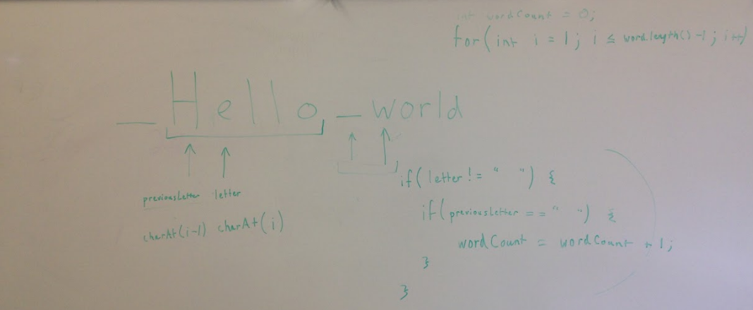

Conceptual Board Work: I was all over the place today. Students were able to understand the idea behind solving the problem. The shell should help to solidify the concepts that we went over on the board today by allowing them to practice what we went over.

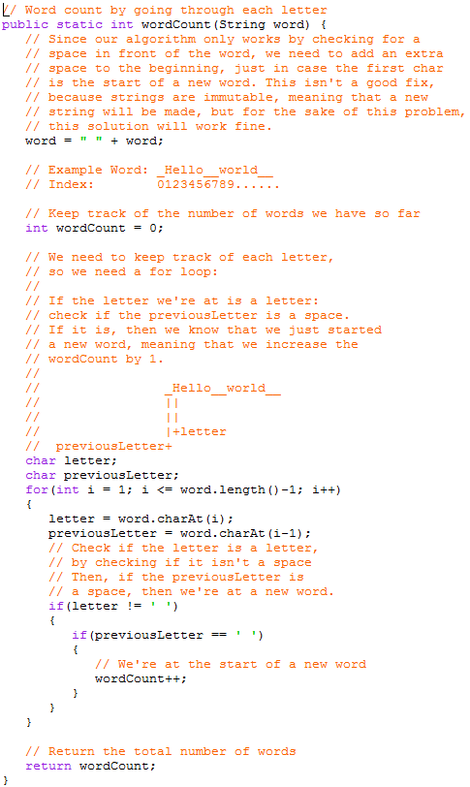

The code that I will be sending out by email. I will be removing most of the code inside the method, but will be leaving in the comments to guide students how to get to the solution themselves.